CARSON CITY ASSESSOR
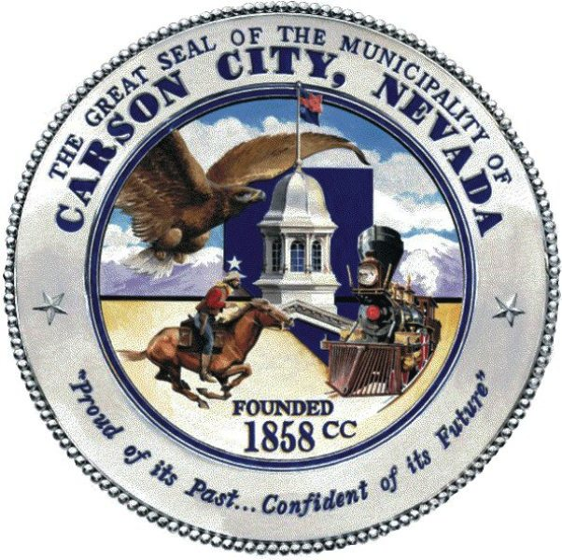
201 N. CARSON ST. STE 6
CARSON CITY, NV 89701
(775) 887-2130 * FAX: (775) 887-2139 * Hearing Imp: 711
assessor@carson.org

CARSON CITY ASSESSOR’S OFFICE ADDRESS CHANGE FORM

Date: ____________________

Owner Name: ___________________________________________________________________

Assessor’s Parcel #: _______________ or Personal Property Account #: __________________
(Mobile Home, Aircraft or Commercial Business)

The property location address is: ___________________________________________________

Please change my mailing address to:

TO BE COMPLETED FOR RESIDENTIAL PROPERTIES ONLY

Is this your PRIMARY NEVADA RESIDENCE? YES _____NO_____

This is my ONLY NEVADA RESIDENCE and is my SECOND HOME:

YES _____NO_____

This property is a RENTAL PROPERTY: YES _____NO_____

This property is FAMILY MEMBER OCCUPIED: YES _____NO_____

This property is VACANT: YES _____NO_____

This property is on the MARKET to be sold: YES _____NO_____

Owner’s Signature: ______________________________________________ Date: _______________

Phone Number: ______________________________________________

